SURREALISM TUTORIAL – WINGS

CROSSBREEDING

➔ Open “horse2” and “swan”
-click on Swan image, Ctrl-A to select all, Ctrl-C
-click on horse2, and paste the swan image into the horse image
-Reduce the opacity of this layer so you can see the horse below
-use the move tool or the arrow keys on the keyboard to position the swan so that the wings align with the horse’s back
-bring opacity back to 100%
-use eraser tool until you get the image below (alternate between large and small erasers – always use soft eraser)
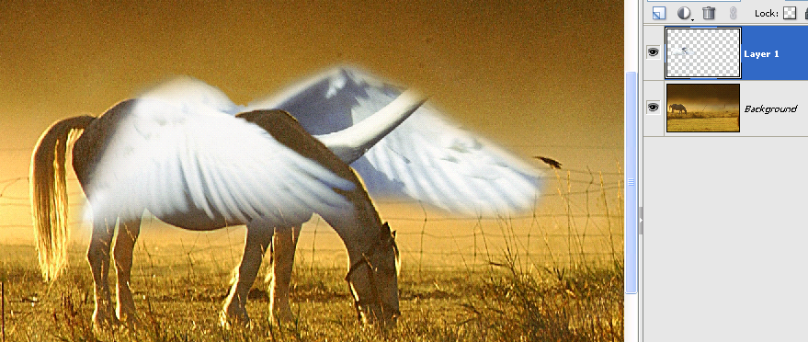
-use the “clone tool” to get rid of the swan’s neck, and to fix any other wing problems. Remember to keep using the “Alt” key to resample new areas and to vary the opacity of the clone tool (try 50%) so that the cloning effect isn’t so harsh.
-When done, Ctrl-U and click on the “colorize” box then move the Hue slider until the color matches, and fine tune its intensity with the saturation slider and the lightness slider.
-flatten image! (see next page for results)

NEXT PAGE….

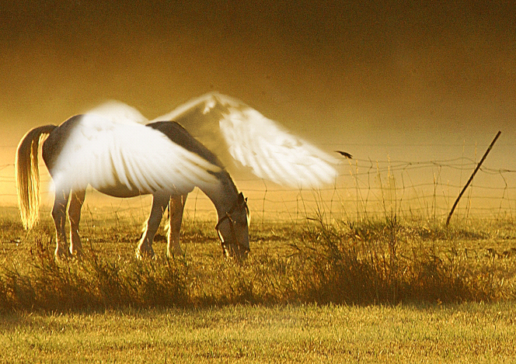

-Look at the Magritte image below and use images in the 03- folder to add wings to a human.
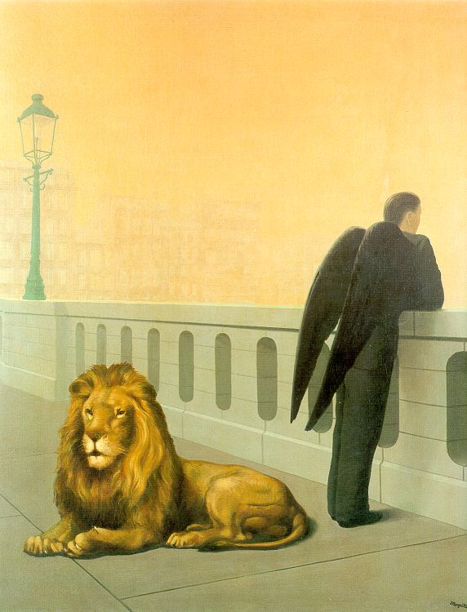

Next page…

How to create flight movement

- Open “jumpingGirl.psd” file.
- Flatten Person and Wings layer,
Then duplicate layer, and CLICK on middle layer.
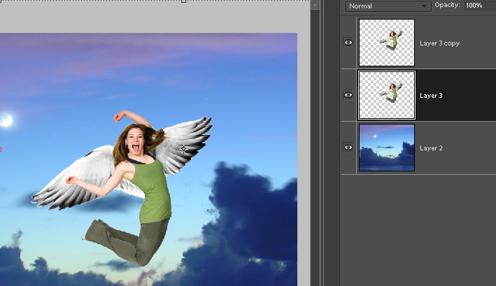

Filter menu / blur / motion blur, adjust the angle and the effect ~ 300 %
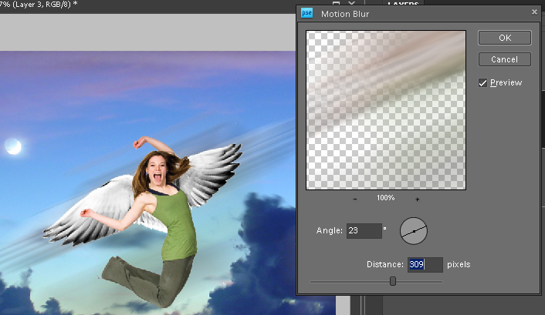

Move the blur to the left, or just erase the right side (this example was moved)
Ctrl-U, and saturation slider moved to right. (You can also use Ctrl-L):

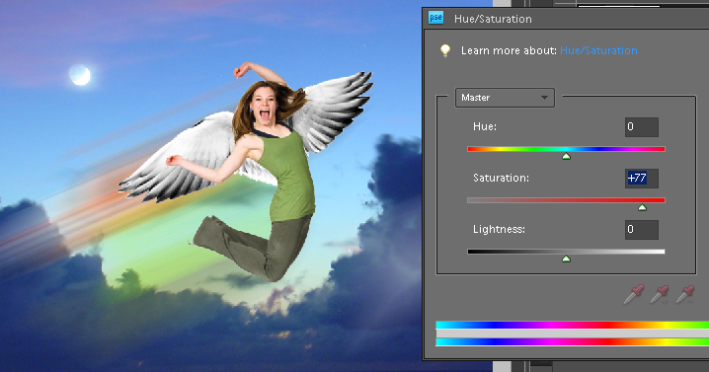

YOUR PROJECT:
You flying, with wings of your choice (insect, bird, bat, whatever you find on the ‘net. Plus background of choice.

